Main Agenda- To create a class manually and add properties in it

For this we need to do the sysadmin > class > create

Before knowing all these things we need to know what is a class what are the types why are they used and what are needed to create and why it is very important in pega

SendSimpleEmail OOTB Email

when we go and create the class from app explorer and then we get the class already inherited and we can specify our class name by giving the -

we have rule instance and data instance

there are 2 types of classes in pega abstract and concrete classes as per rule

external classes

if we give class name as we want then inheritance and reusability would be a problem

abstract class if selected we do not have any instances

every concrete class will have the instances and would be saved to the database table concrete class mapped to a database table for sure so that instances would get saved in the database table

for any class if an object is crewated that means instance is created in java it is an object and in pega it is called as the instances also called object creation and also called as memory allocation and also claled work object creation or else called as the case creation all come under the same meaning

for suppose we have a loan request case and one case is created that is

l1 here l1 means instance each instance has an Unique ID

based on the no of requests that many instances are also created by the PRPC

50 requests 500 instances if we want to save these instances permanently into the DB then we must create a concrete class

if we don't want any instance and we don't want to create it into the DB table

pega automatically maps class instances into the database table

for integrations almost we create Abstract classes beciase they are not related with the because it has no relation with workobjects and instances becuase from REST or SOAP we get the data temporarily from DB and temporarily and we do not have to use a workobject to create instance and save it

int and data classes would be having the abstrac work classes would have the concrete classes

organization classes or division classes

pega shows that it cannot have instances it does not have keys defined

work class will have instances

it will have rules but not instances

Data-Admin-DB-Table rule associates the concrete class with the DB table

and even our work classes created are also instances of other class and not only a class but property created are also a instances of other class when we go for a class and click on it we find a instancs of the class that means all are having some instance of the class

above all these pega classes and work classses also other classes also provided now what are those classes means those are as shown as below

rule-obj-class

rule-obj-ruleset

rule-obj-rulesetversion

rule-obj-property

Below are some examples of the classes attached

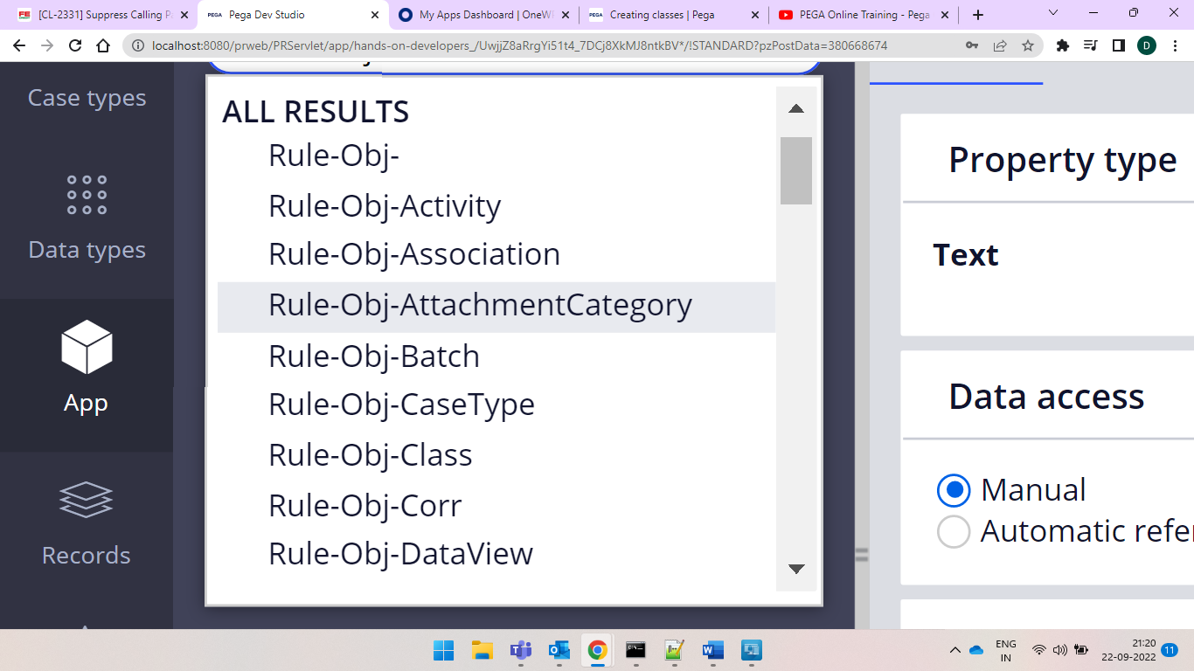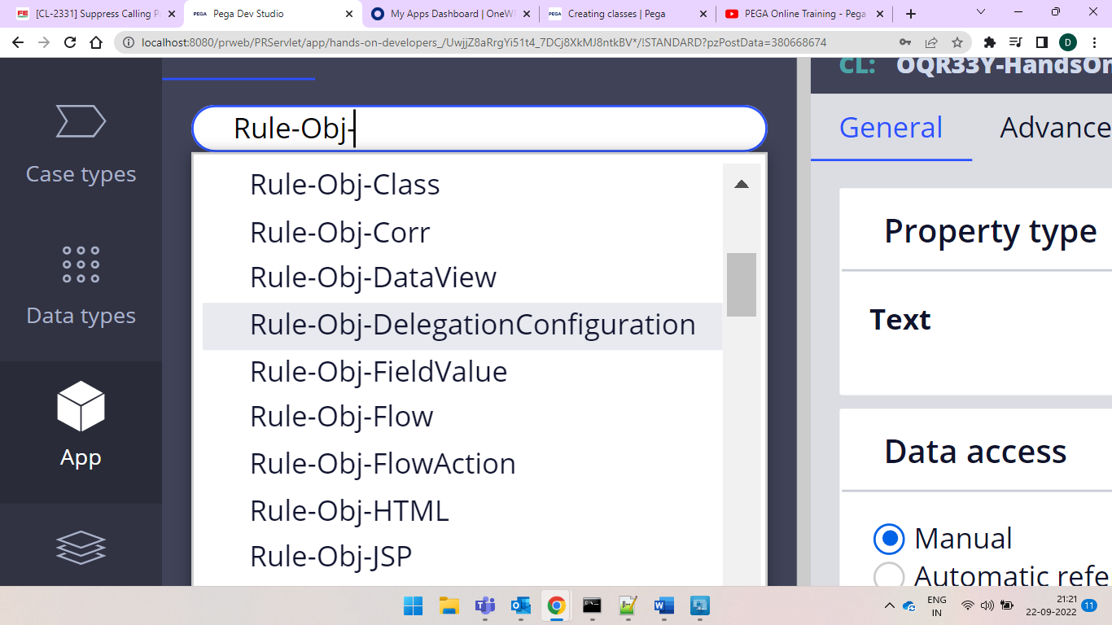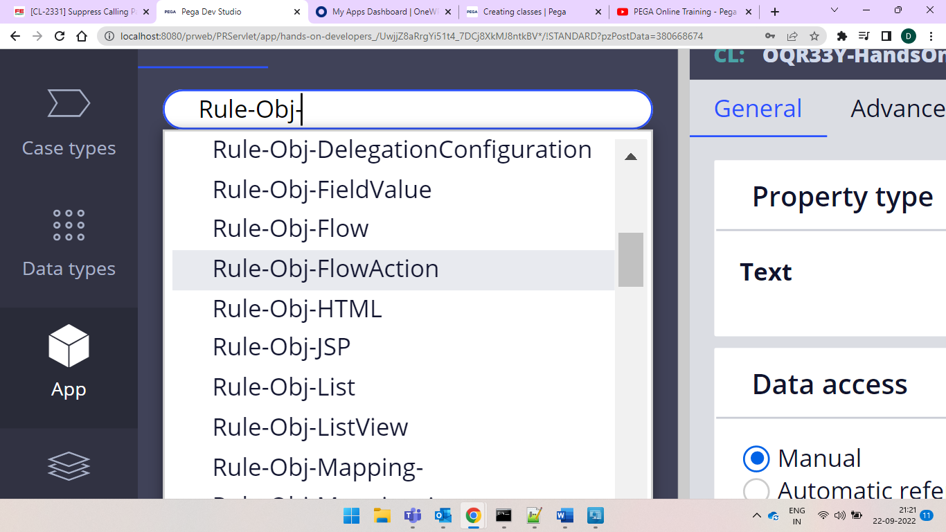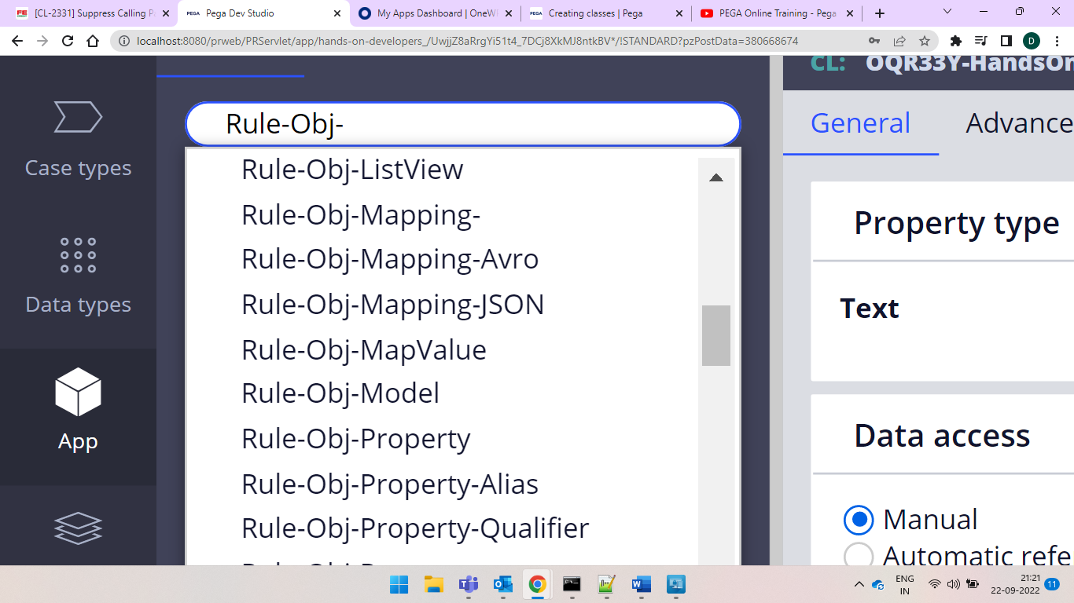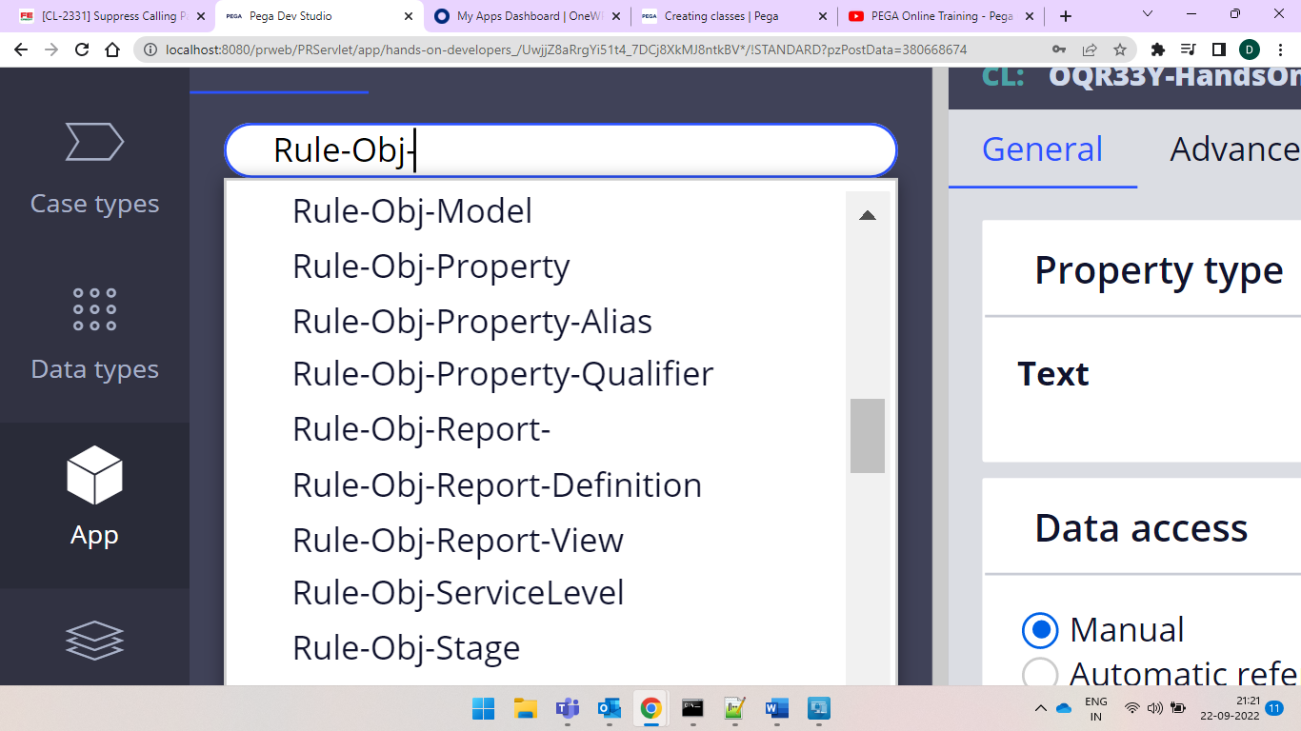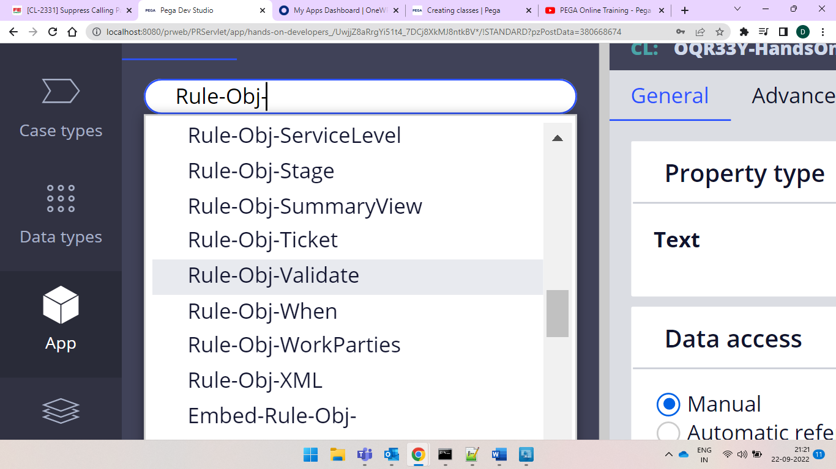

waht are all these that means whatever the property that has been created acts as an instance to this rule-obj-property

every rule has an ID which is called as pzInsKey

So if created woith same name under same class and under thing we would find it as rule already exist but with same name if we create a report that would go under rule-obj-report

based upon our selection we have that many classes

if we search in pega as rule-obj we would get almost like every rule has class

we also have embed class that means it is a parent to other class by design, and are never to be used as a top level structures.

the Embed-Env classes included in Pega Platform, and the default environment properties that each class contains

some are also created as part of data instances not only rule instance if you can see we can see as data instances for example data-admin-operator-id your created operator ID is an instance of this data classes.

Best Example is DSS

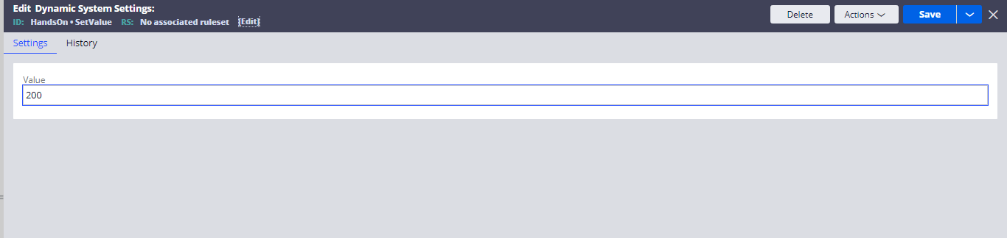

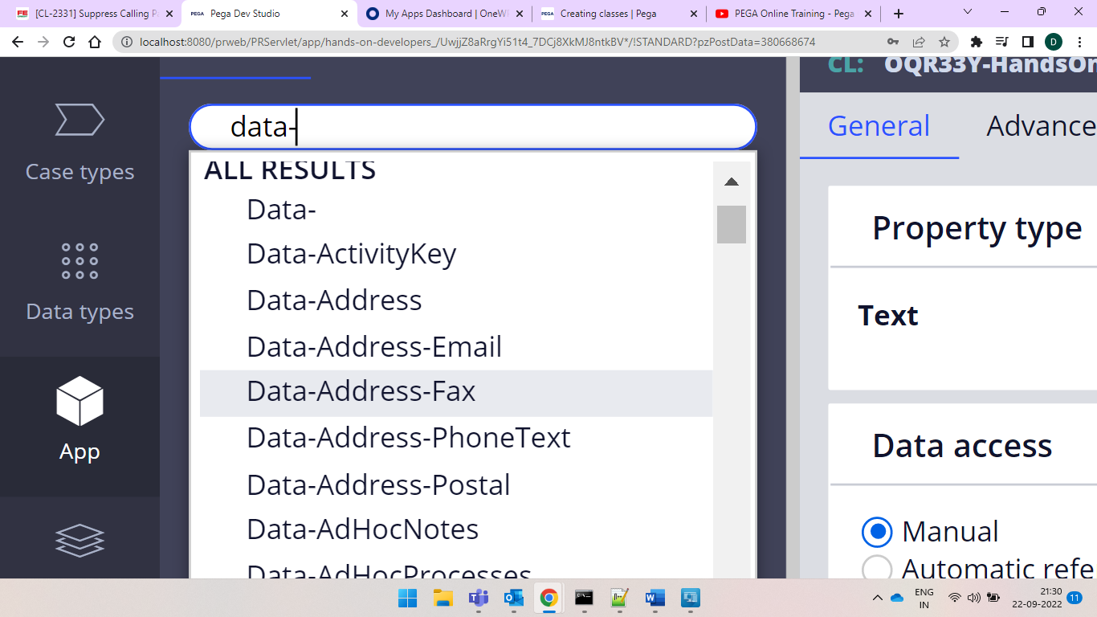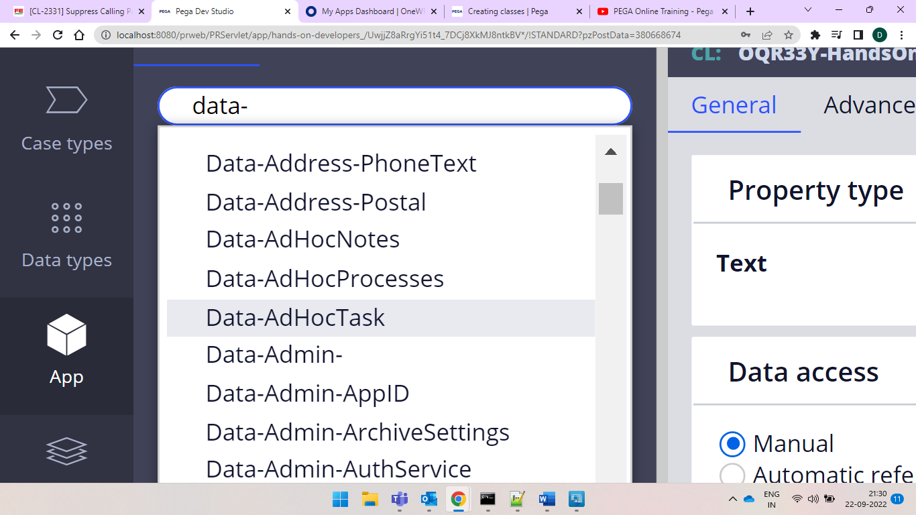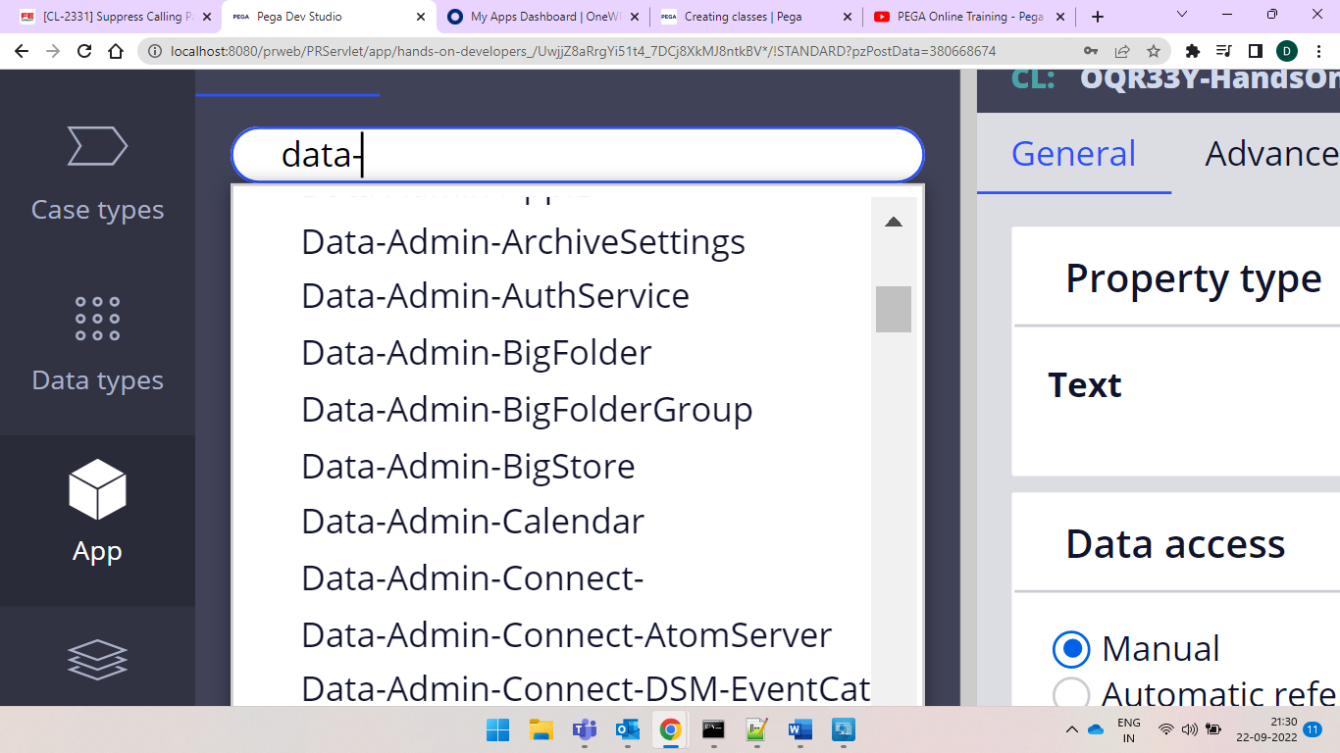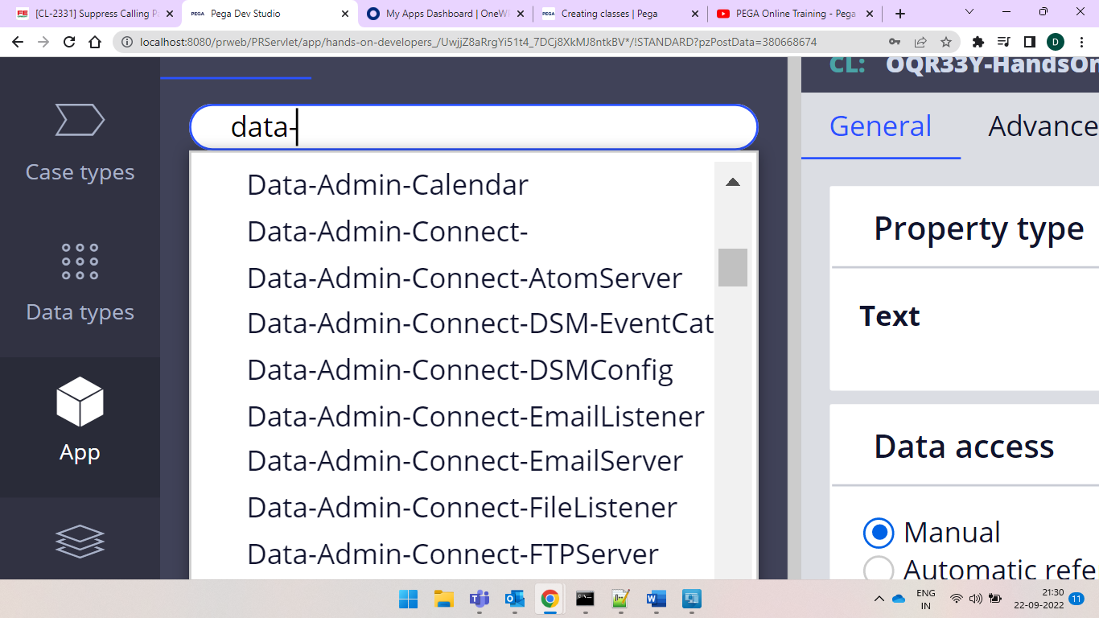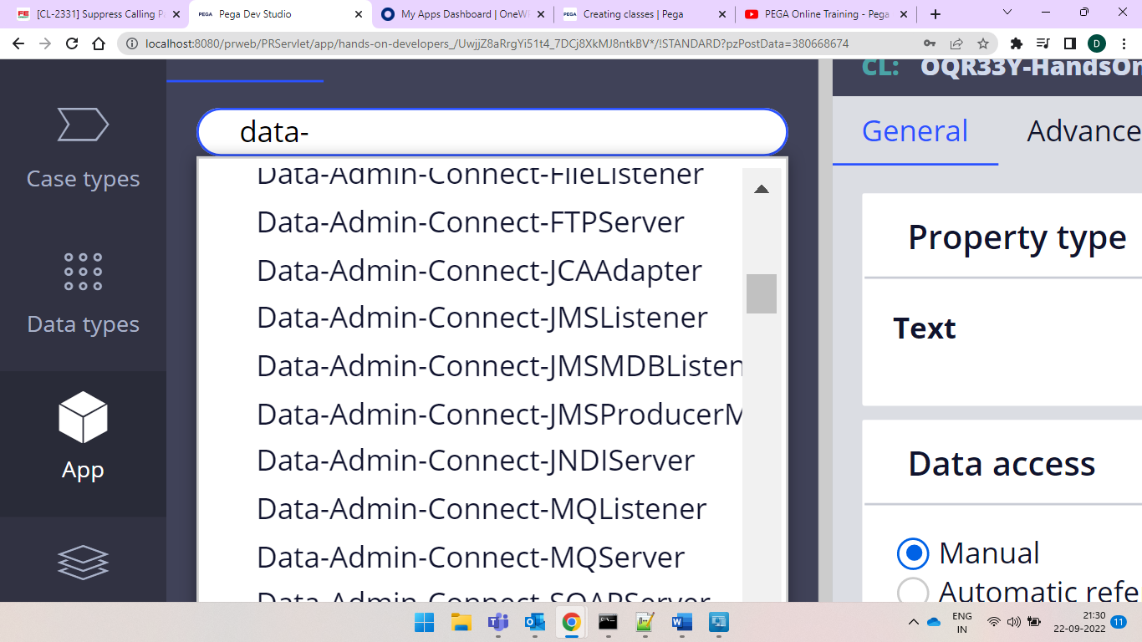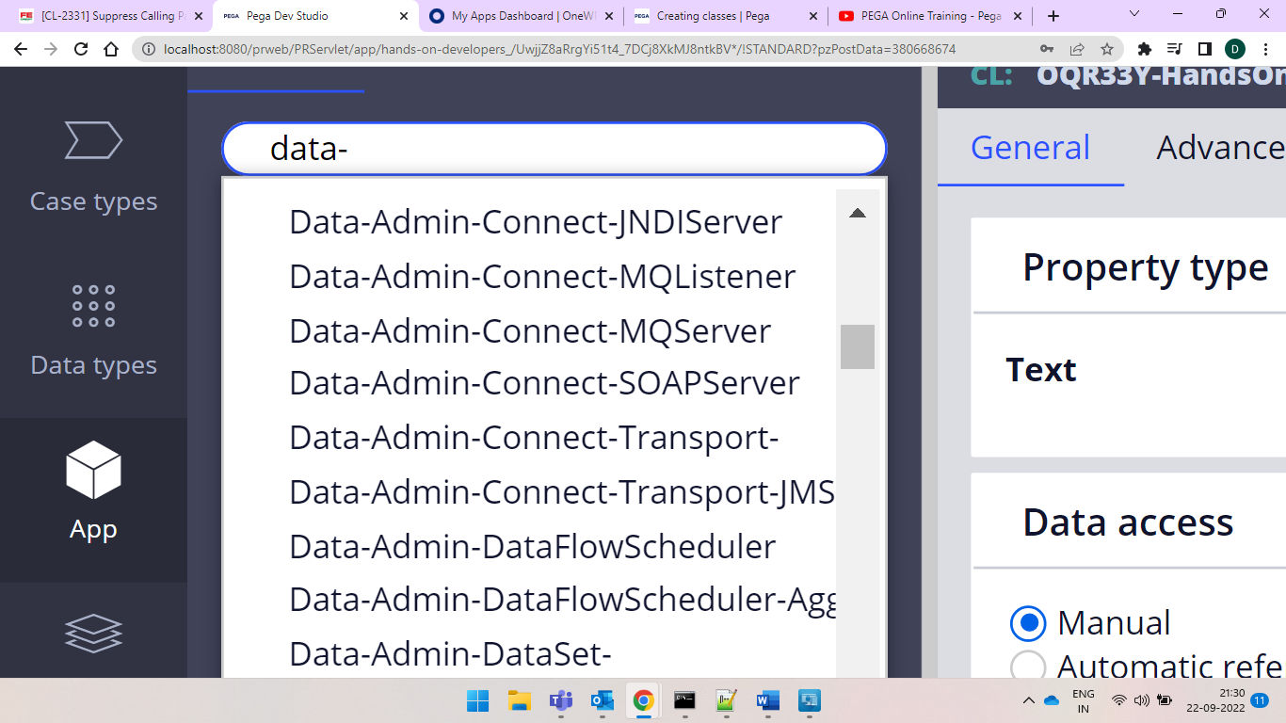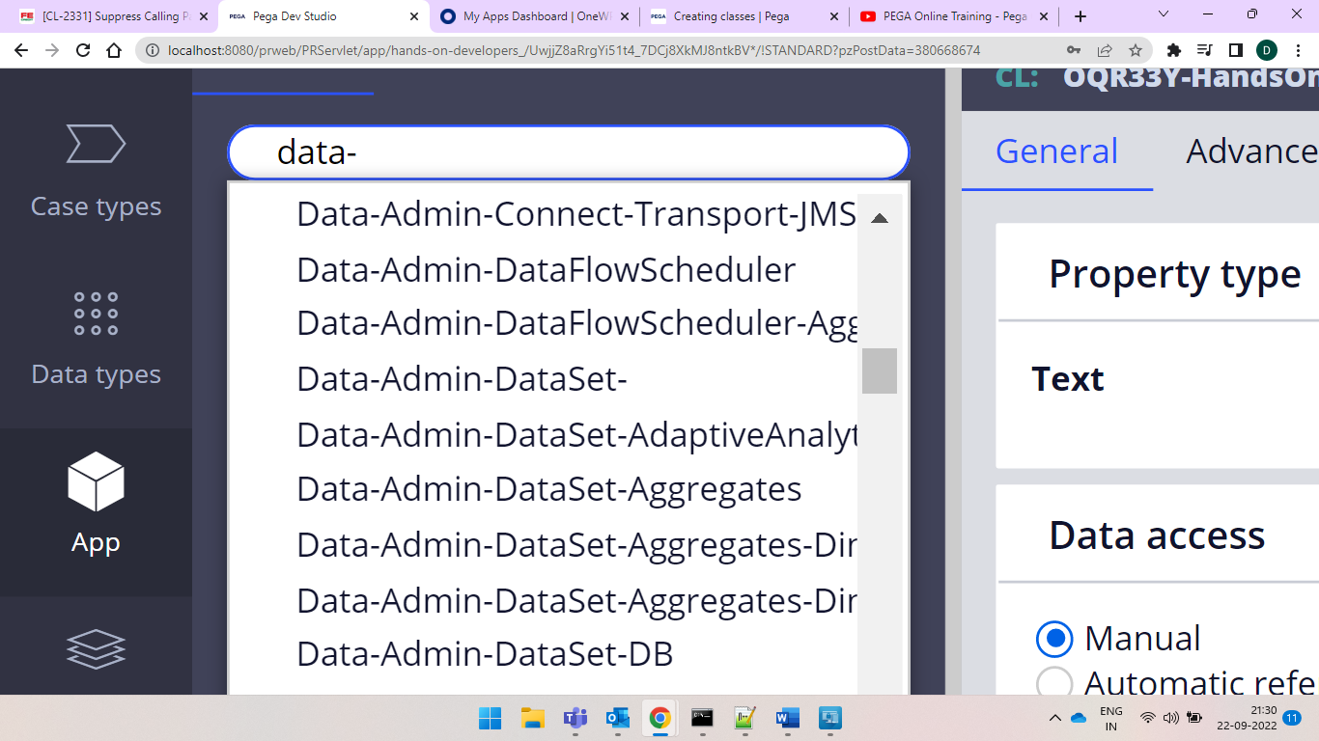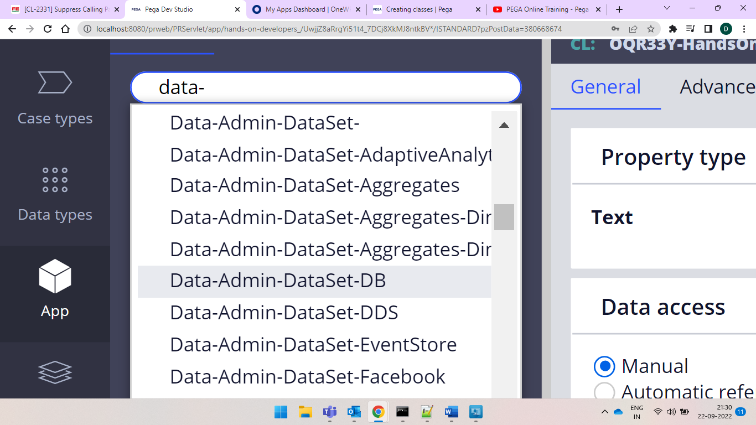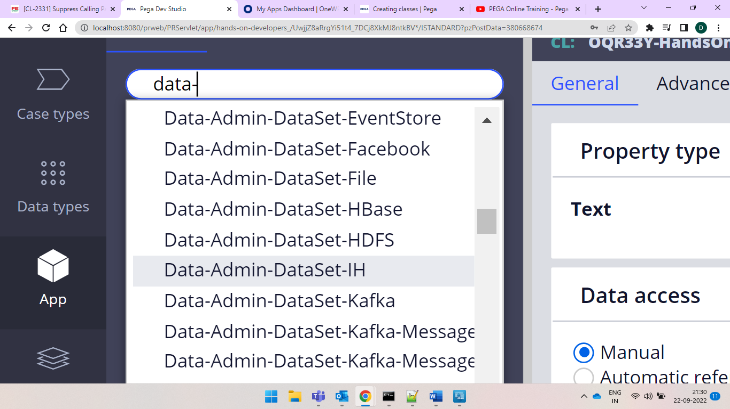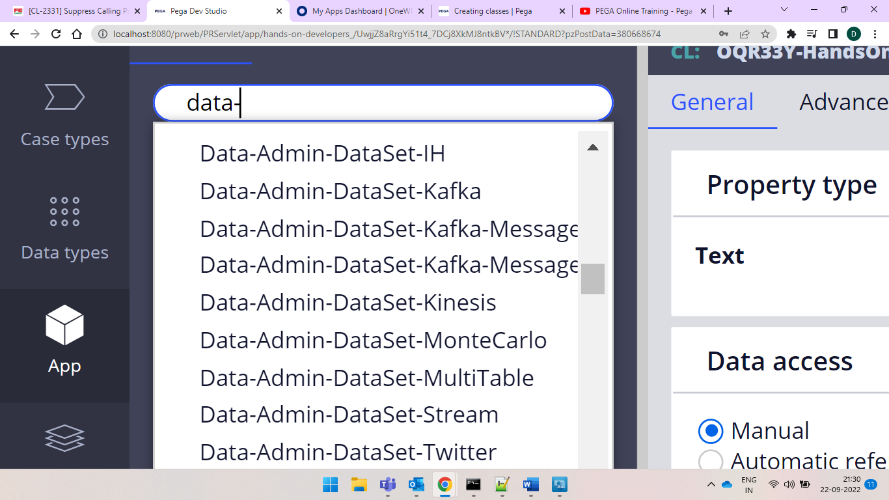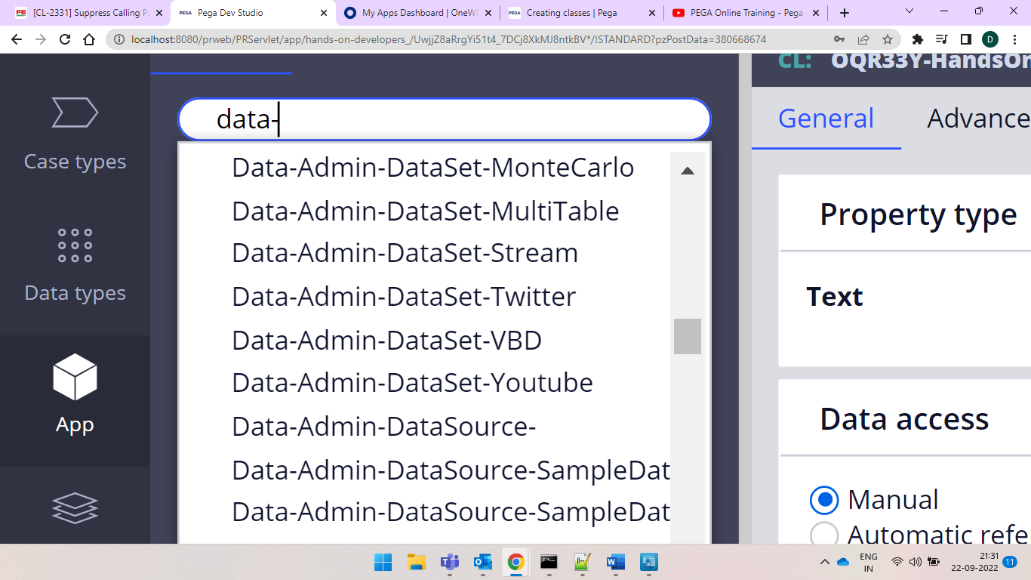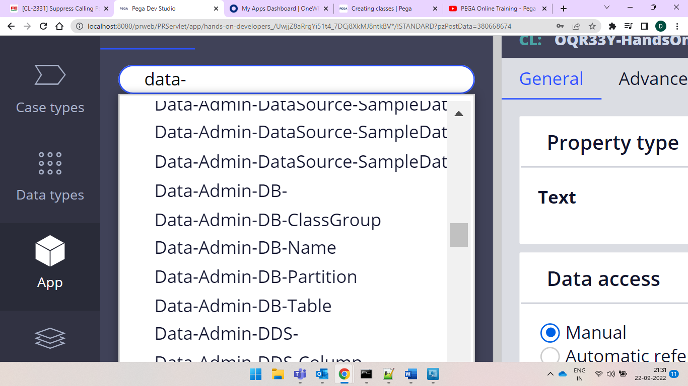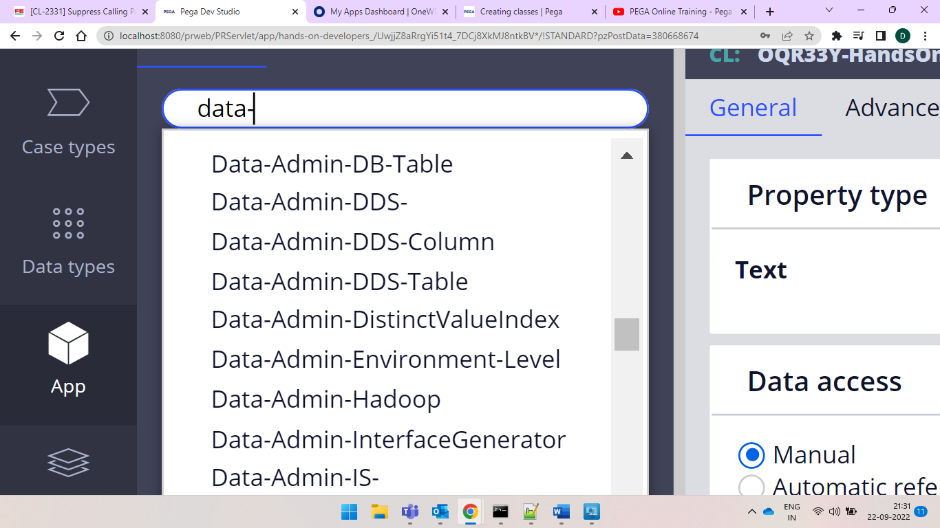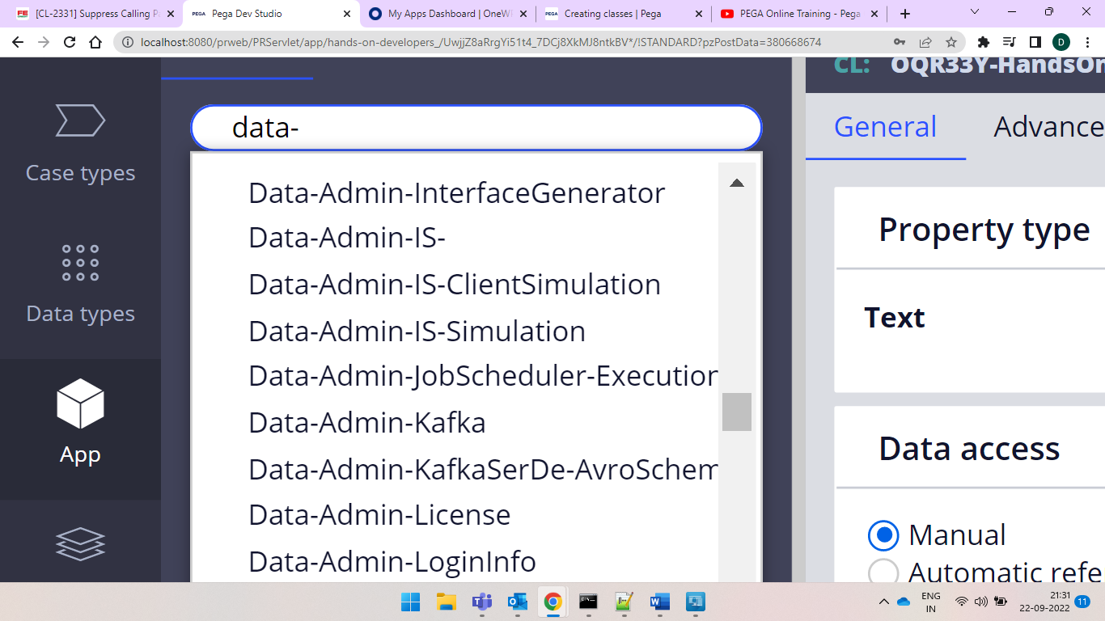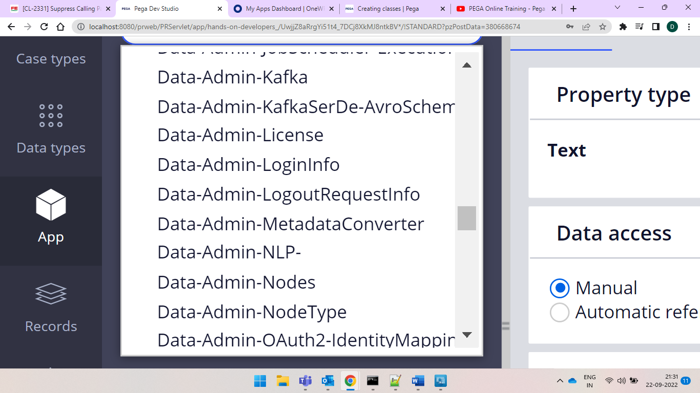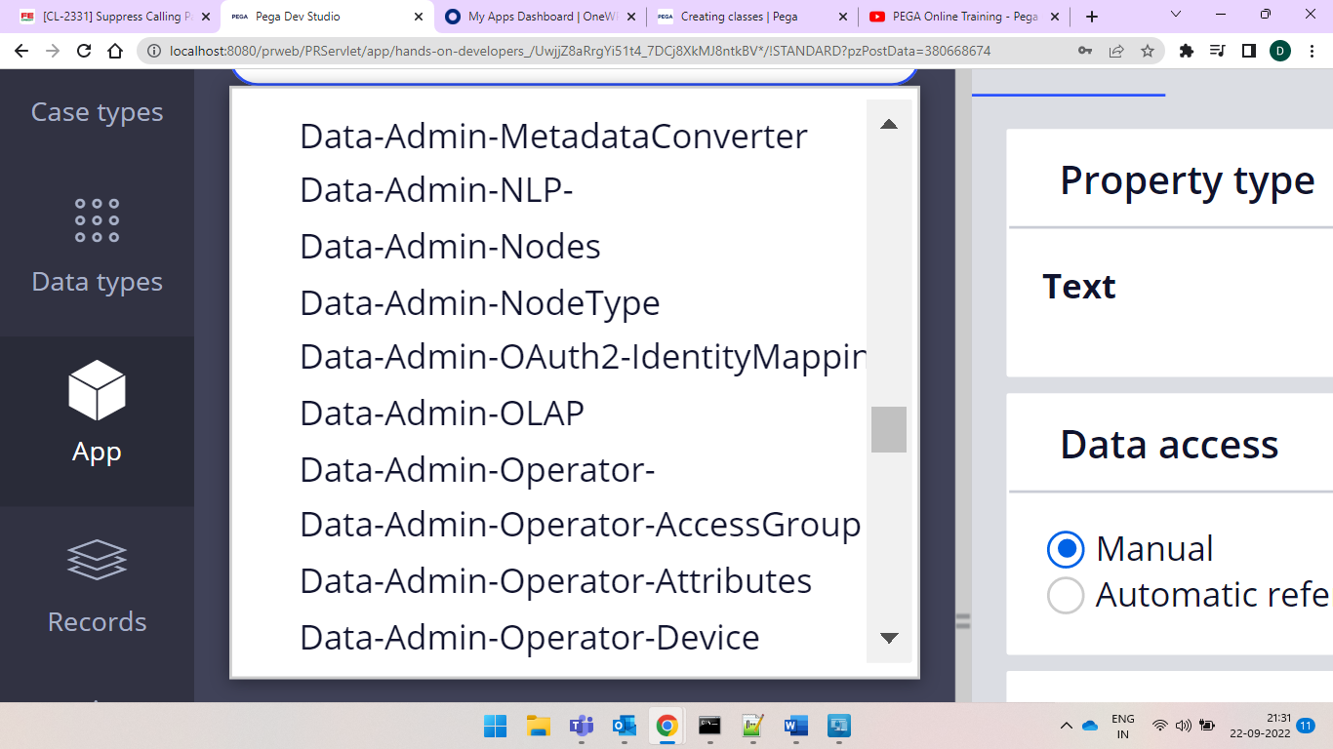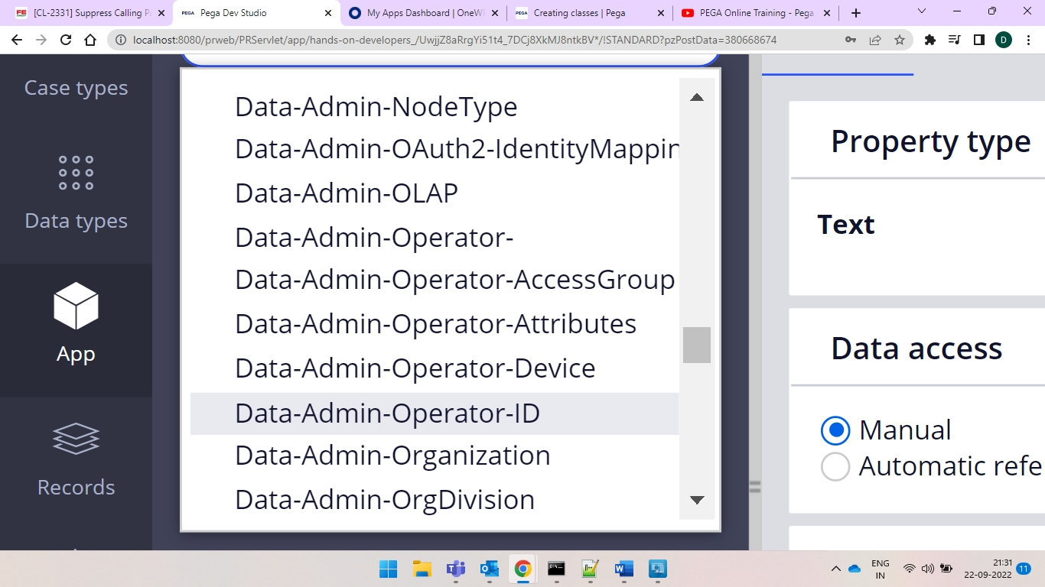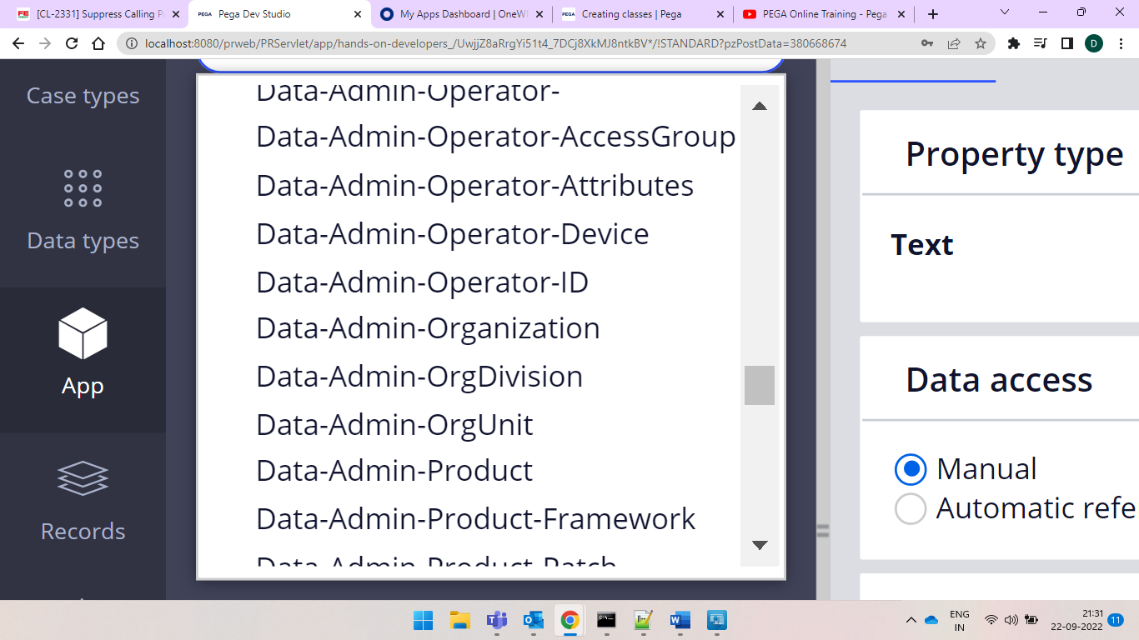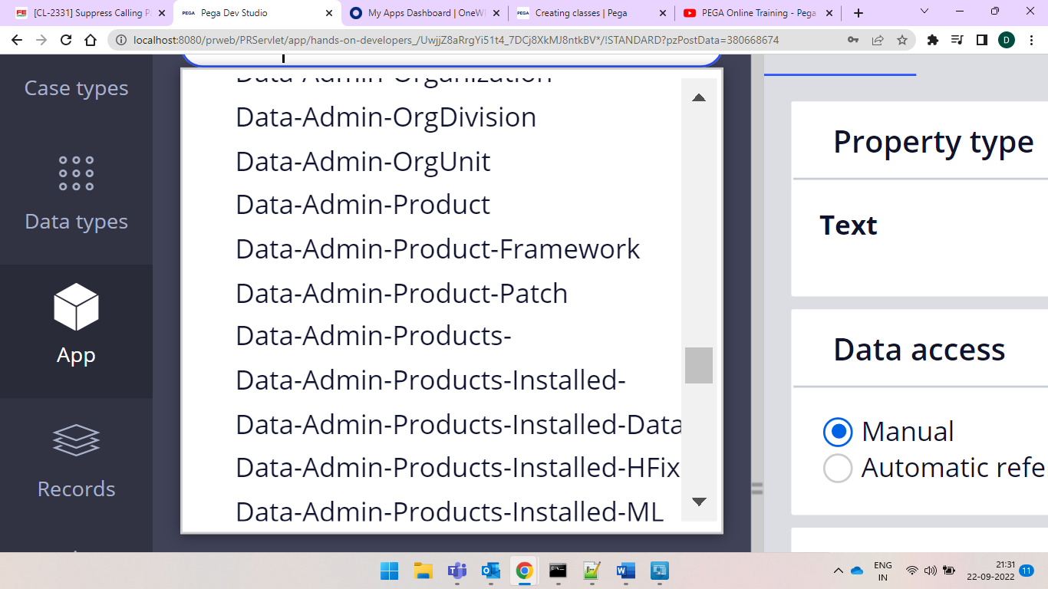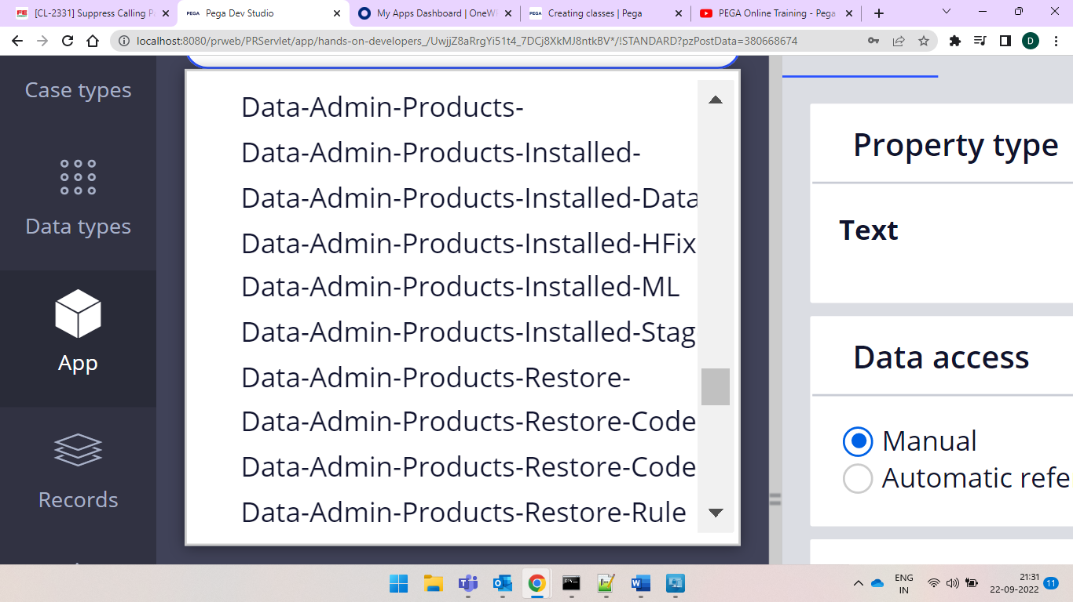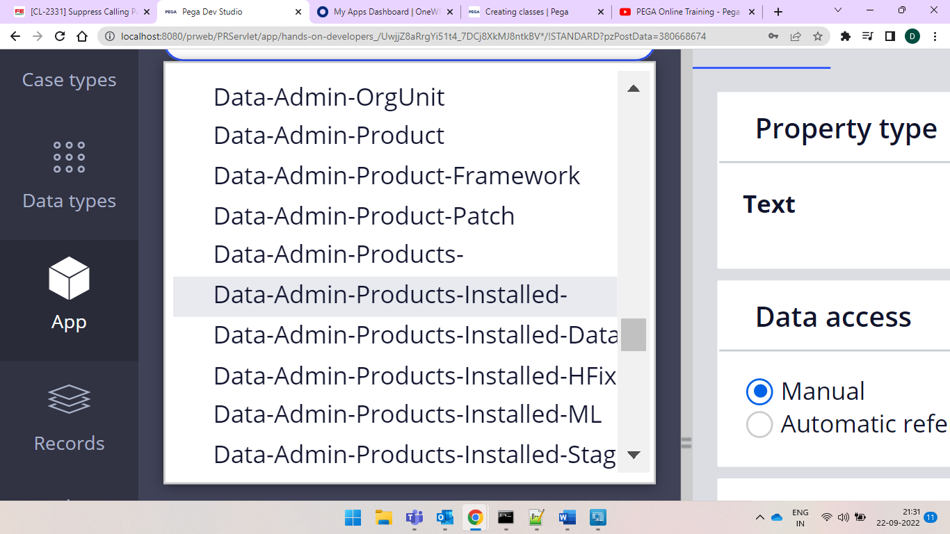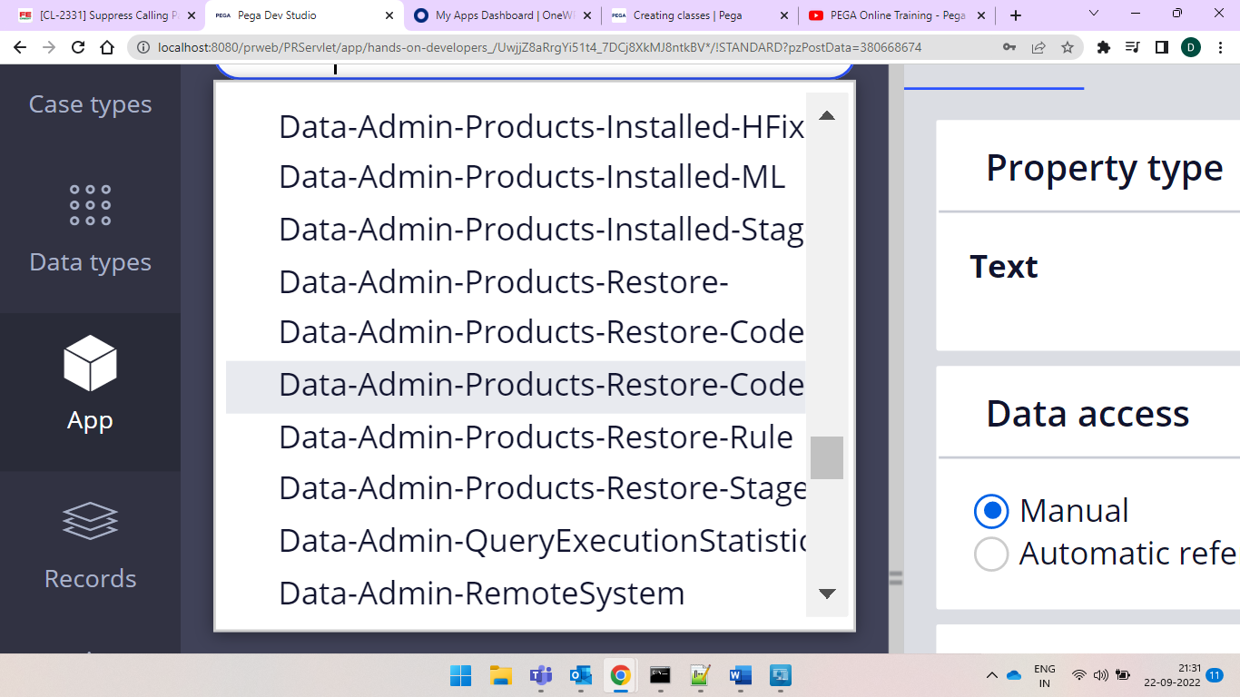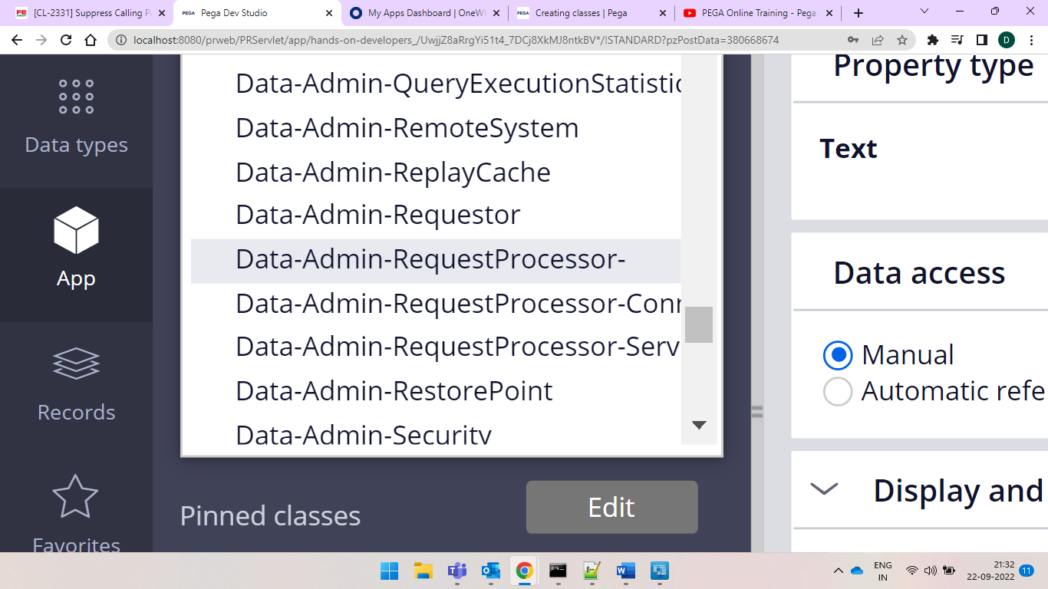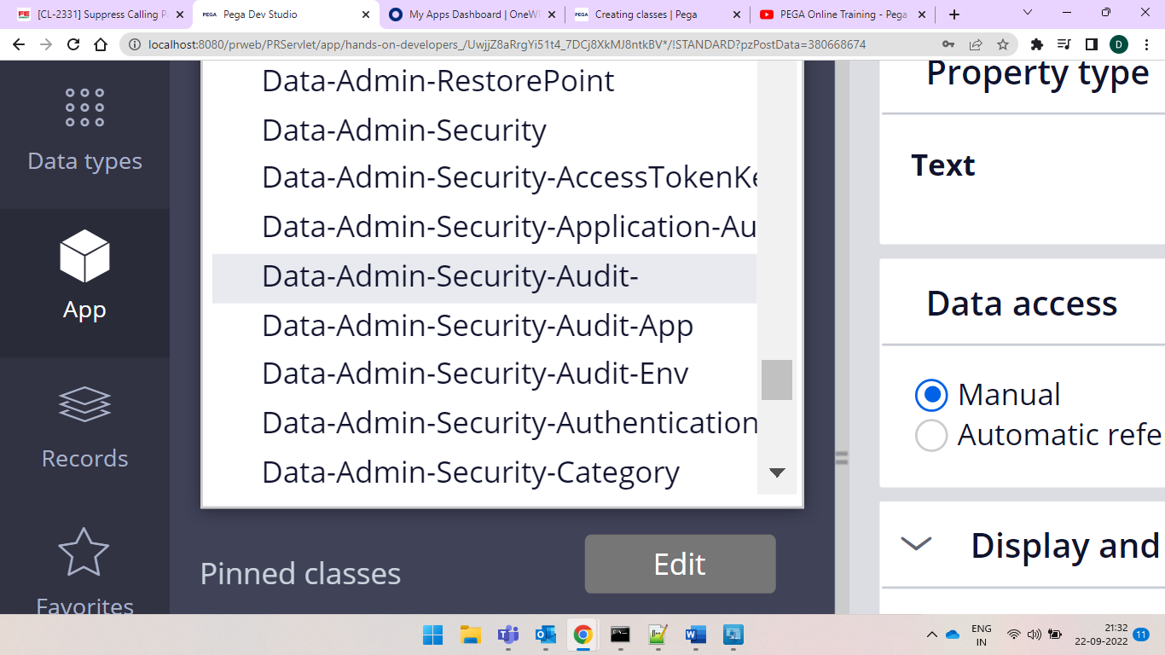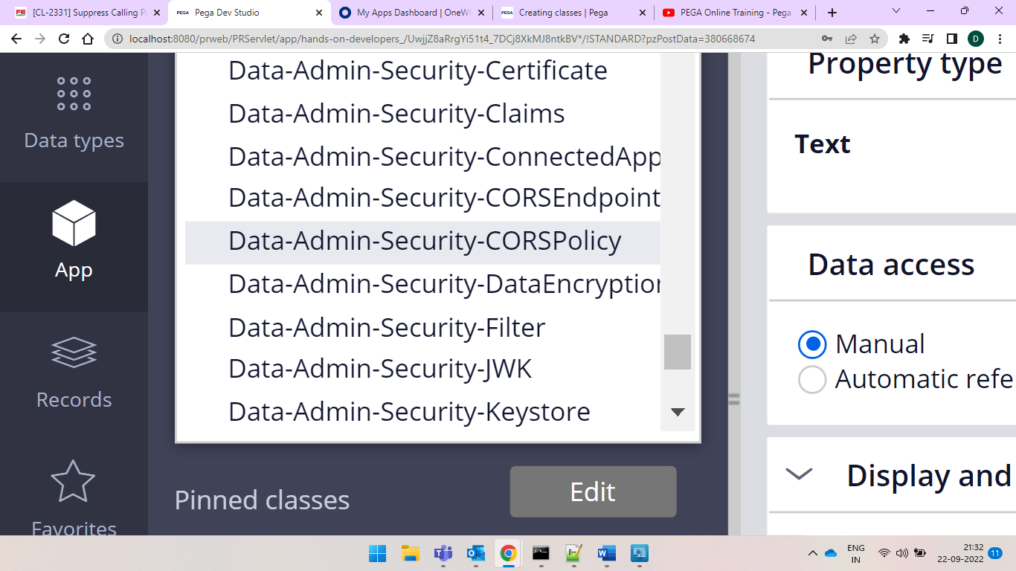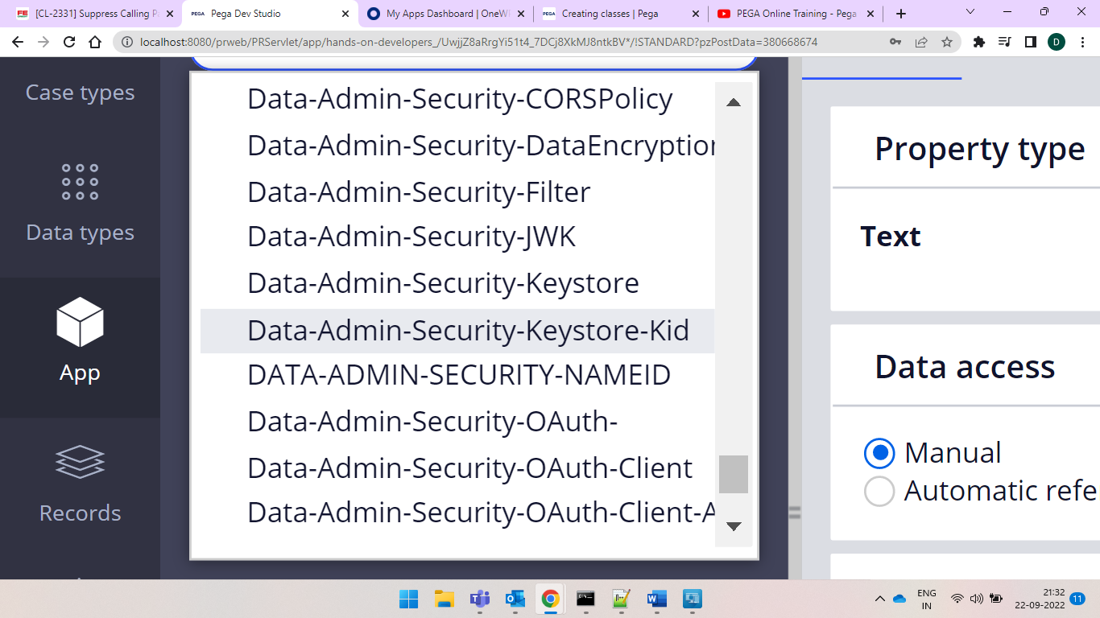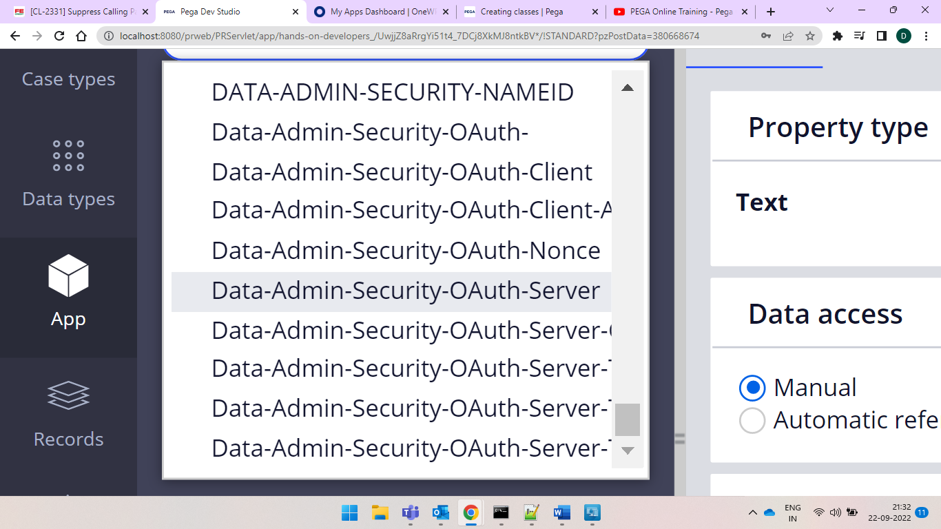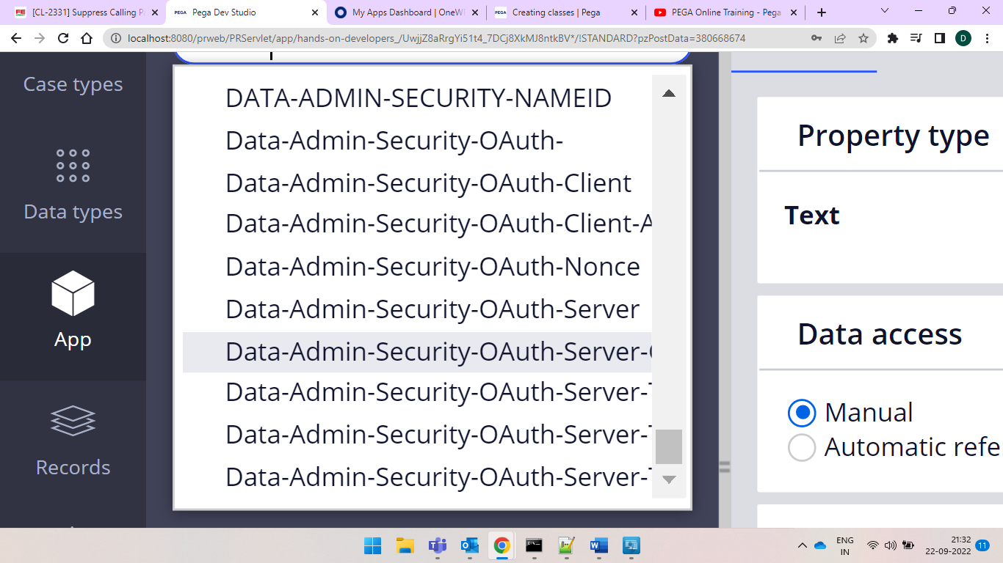

and data instances do not have any ruleset version for this anothjer example is dyancmic system settings if we open any rule we would find no asssociated ruleset and also can check pzinskey for the xml

we need to give the naming convention properly

org-div-unit-application

our application has org class div class

if we change from the abstract to concrete class we have more options and in abstract just inheritance is followed

and if concrete class is created then we must and should specify whether it is belong to a class group or does not belong to a class group or it is itself a class group which is used to manage the instances in a database table and for every instance ID is created and they get permanently also stored in the database

each and every class is mapped to a database table pega automatically creates database table

ifwe take any class structure and give it as the

Aret-Loan-Vehicle-Work

in this work is only the concrete why this is only given as concrete class because so that any other if given then the isntances f those would automatically get created and save all the data and under it we have it under database table and when we have it then we would have it as the under work what use we are creating it then we would have the instances and get created

ex-

Aret-Loan-Vehicle-Work-ProcessPLoan(ProcessVloan)

Aret-Loan-Vehicle-Work-ProcessHLoan(Home Loan)

and after work when we create our case type and that becomes as a concrete class under work

and if you want ot create all these classes under one database table then that belongs toAret-Loan-Vehicle-Work this class group only

work class always becomes a class group because it can maintain/hold other class instances also so it is a class group and with same name class group also exists

so we cam to know that the instances that are under the processsPLoan would also be mapped to the same DB table of the work class

if we want to maintain a seperate DB for the new class then can select as is a class group and automatically

class gorup would be changed to your new class and class group also gets created

and we use the keys and that means concrete class has instances and it would have an unique ID which is also called as Case ID Work Object ID etc...

and we cna give the keys as the pyID it is an built in OOTB property which is used to maintain Unique values also can be called as primary Key

one and only principle if any thing is holding data that is a property only.

If you want to get the

class creation

we can avoid to use the names that starts with Code- System- history- because the system creates them automatically

in the label field we need to create the unique ID under multiple combinatins then we can give multiple keys

if you don't want to give pyID and you want to generate a unique ID and then can check the checkbox

while isntalling pega only we would find under the test connection for the concrete class and postgrey SQL would get installed with it only

we need some schema then only the application runs and installation would be done and interaction would be done with the database tables if that fails applcation won't run. we can find the postgrey SQL also in our task manager and it would run behind normally would connect to the database but to connect here he gave the GUI ID servers provided by pega what is it means we would connect through pgAdmin III client tool

and application rules would always be in application schema

in data chema we would always have the transaction tables of the application or application related data information would be under data schema

and in the rules schema pega related data is stored means if we create any rule that gets saved into the rules schema

and we can know the configuration between class and the database table which we can find under the

Data Model classes and prperties database class mappings

here we can see the table mapped to the class

if anyhting is mentioned as a workpoool tha means it has to be a class group

and when we select belongs to a class group

when selected does not belong to a class group is like maintaining a seperate database and

differnce between is a class group and belongs to a class group

in does not belong to a class group means it cannot store or save instances of the other classes

if mentioned as is a class group that means it is ready to accept the instances of the other classes

there is a relation between parent and child that means it can store instances of child also

but in case of not a class group there is no relation with parent and child classes

and you cannot create a work class with selecting an option as the does not belong to the class group

classes inheriting from Work- directly or through an inheritance must belong to a class group

all the case related rules belong to the Work- , Work-Cover

and if we give baseclass then while creating work object issue would occur so i should inherit from work- inheritance only in this case you can create it as a data class

al data classes are created as a does not belong to a class group category only

if instances are present in data class and if it wanted to map to a database and then it is does not belong to a class group and if we do not have any instances we should select as abstract class.

and if the work class is not inheriting from the work- then you can select it as the does not belong to a work class

for example we have countrieslist that means if having a doubt whether to create in work class or data class then can take this as mastrer data and it does not belong to any workobject and can reuse where you want and such individual entity you can create as the data class and then can map in database table.

ex- customerlist

product list countries list operator list

and BLOB is used to store binary data

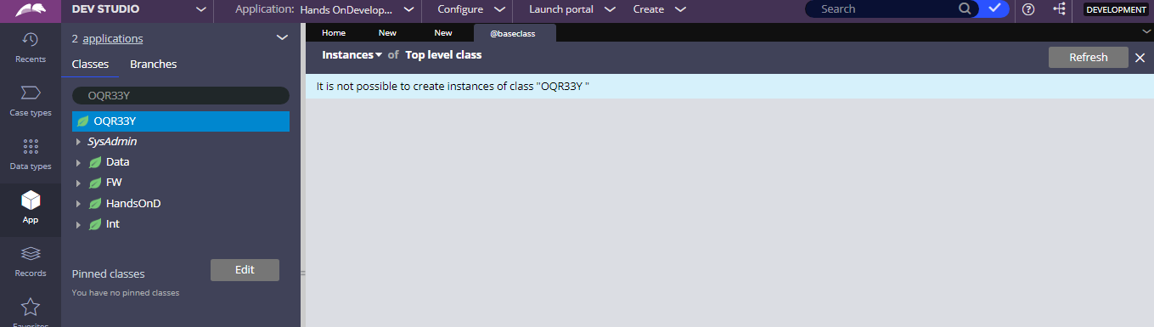

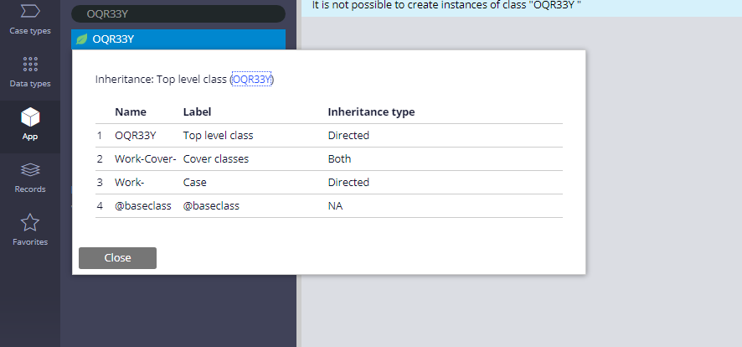

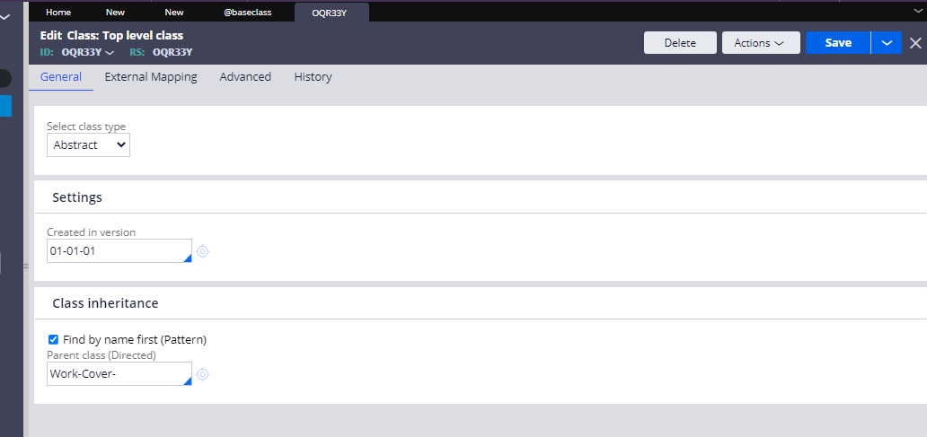

This is the abstract class

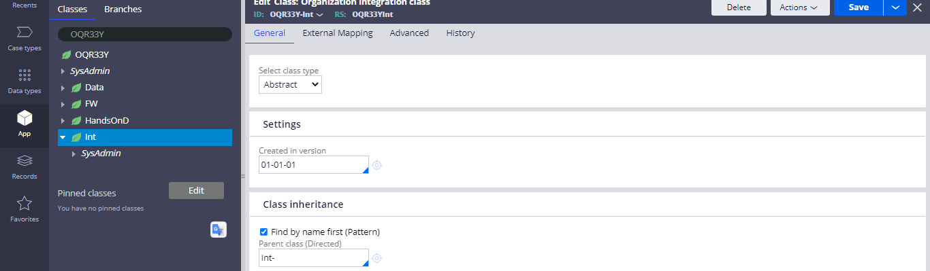

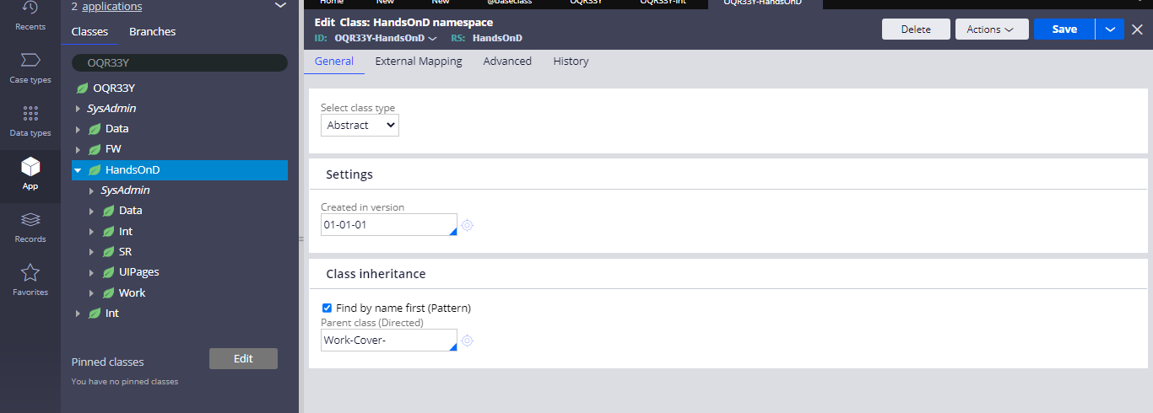

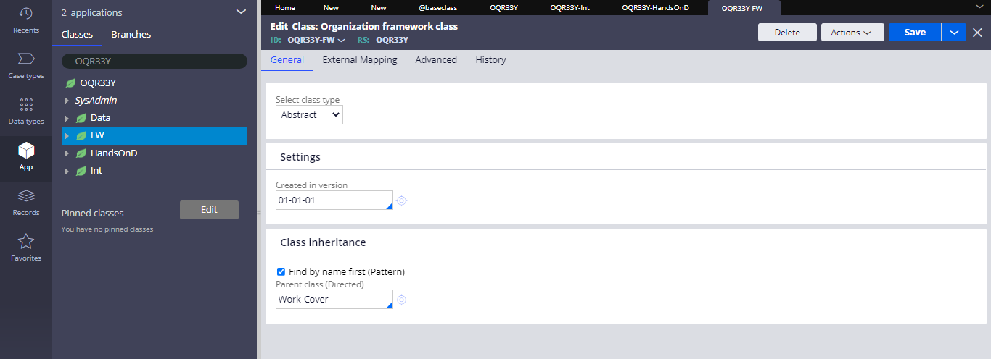

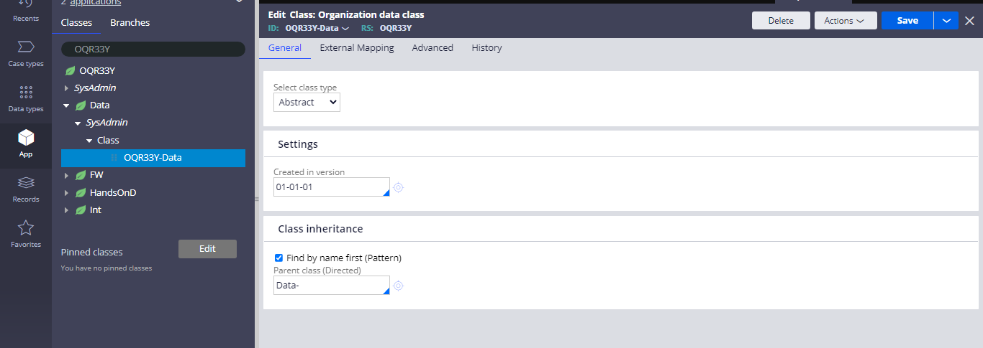

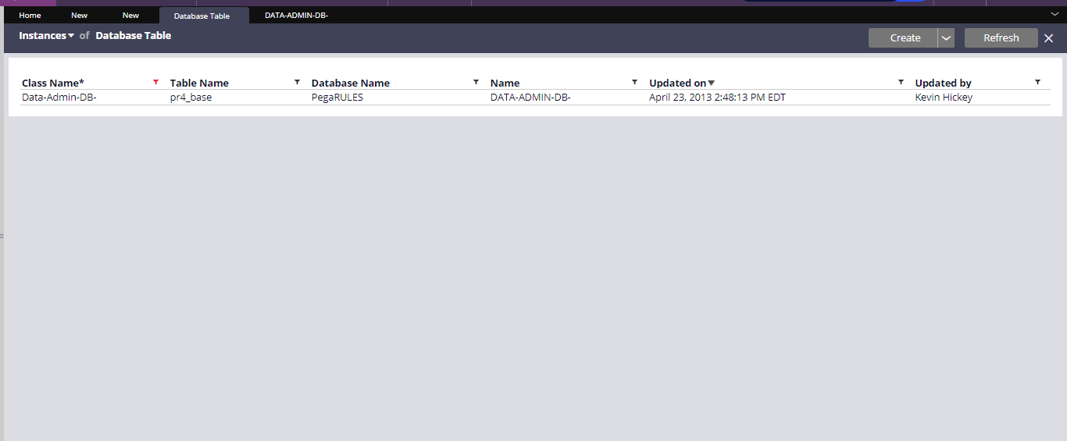

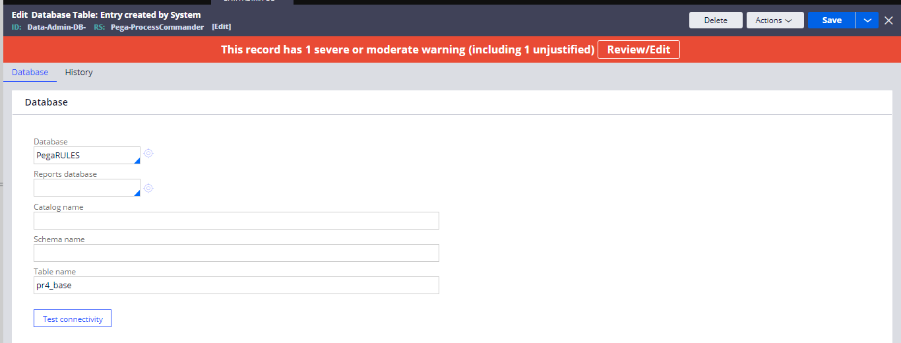

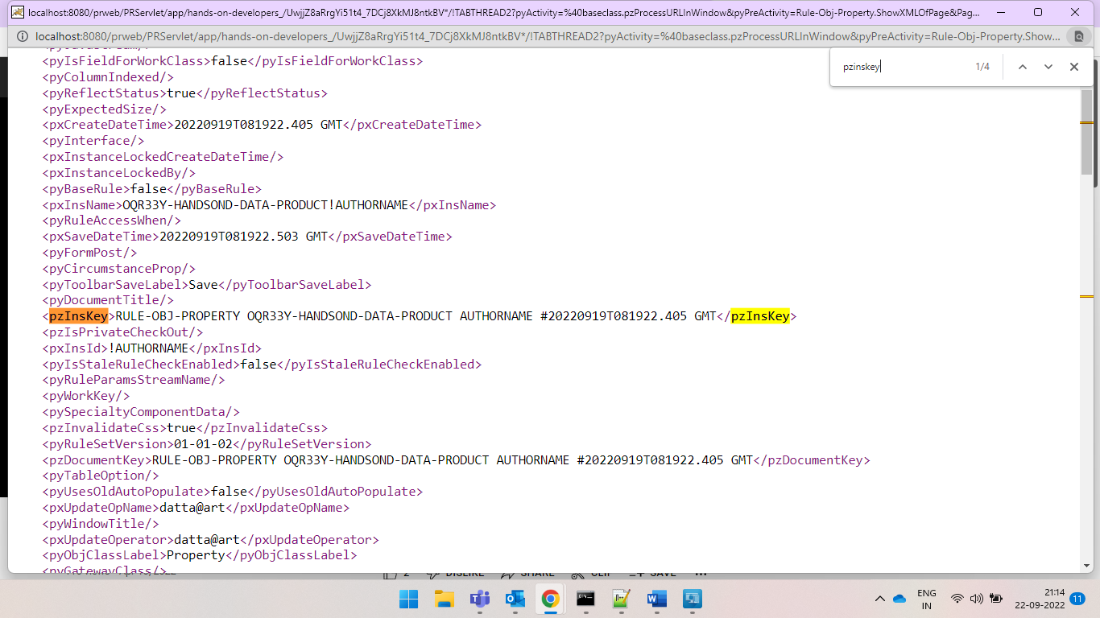

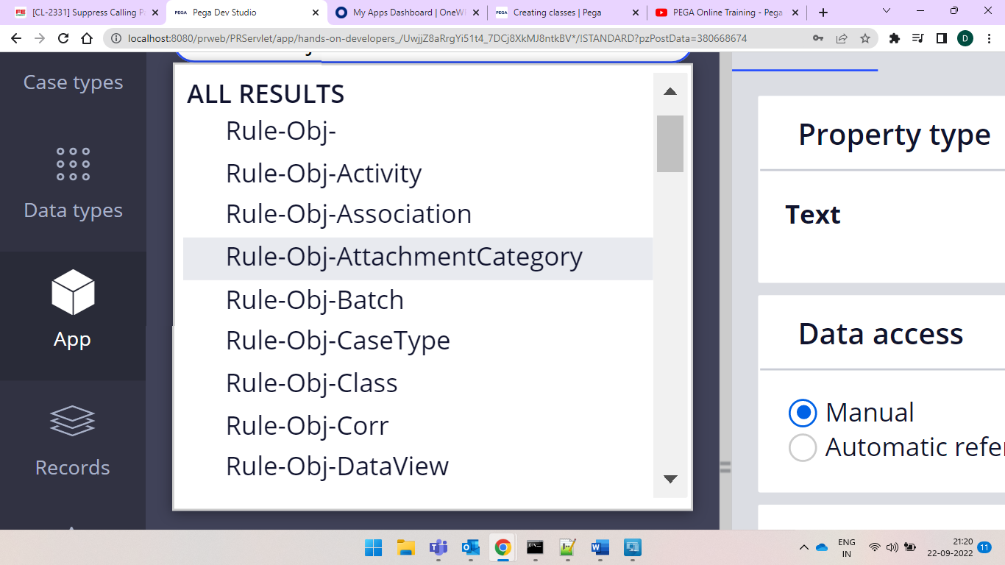

Best example is



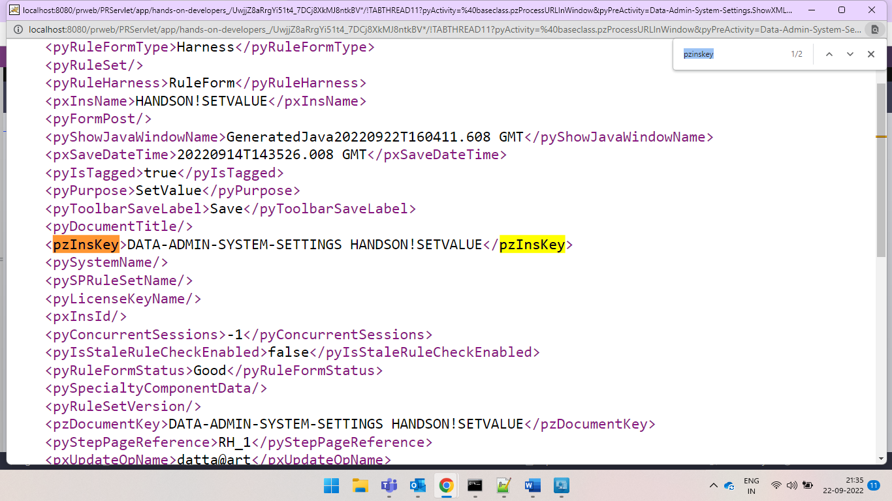

And also for finding these we have class mappings

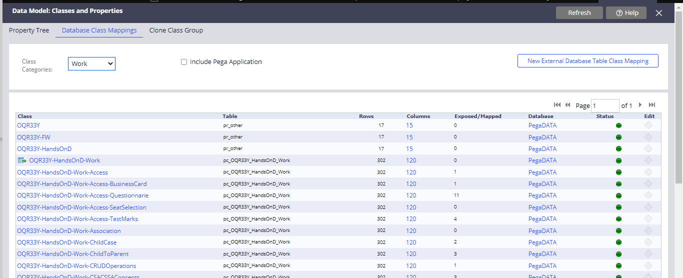

And now I created my class as

Aret-Loan-Vehicle-Work

Where

Organization is Aret

Division is Loan

Unit is vehicle means loan provided under vehicle

And work is for the class instances storage

And properties created are

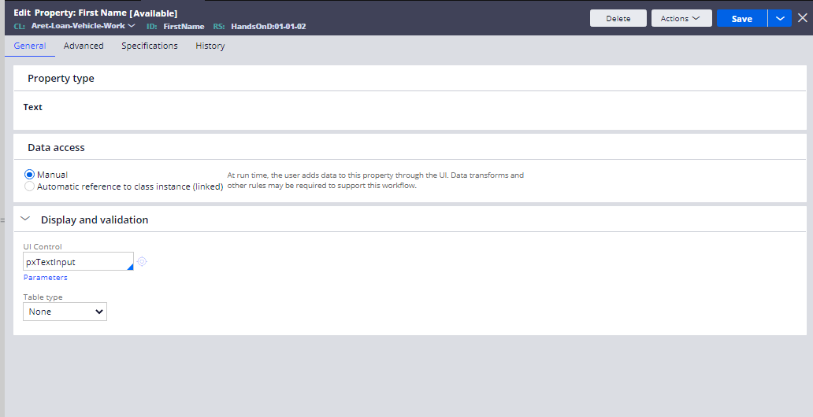



And changed in the operator ID

